**SUPPLEMENTARY REPORT – 25 March 2021**

|  |  |
| --- | --- |
| **Panel Reference** | **PPSHCC-49** |
| **DA Number** | **DA 2020-567** |
| **LGA** | **Maitland** |
| **Proposed Development** | **Residential aged care facility (168 beds, demolition of existing facility, tree removal, car parking, signage and associated site works)** |
| **Street Address** | **7 Martin Close & 42 Stronach Avenue, East Maitland** |
| **Applicant/Owner** | **Churches of Christ Community Care** |
| **Date of DA lodgement** | 19 June 2020 |
| **Total number of Submissions**  **Number of Unique Objections** | * Four (4) * Three (3) |
| **Recommendation** | **Approval** |
| **Regional Development Criteria (Schedule 7 of the SEPP (State and Regional Development) 2011** | **Schedule 7 – Part 2 General Development over $30 million.**  The estimated capital investment value is $36,737,968. |
| **List of all relevant s4.15(1)(a) matters** | * State Environmental Planning Policy 55 – Remediation of Land * State Environmental Planning Policy 64 – Advertising and Signage * State Environmental Planning Policy (Housing for Seniors or People with a Disability) 2004 * State Environmental Planning Policy (Infrastructure) 2007 * State Environmental Planning Policy (State and Regional Development) 2011 * State Environmental Planning Policy (Koala Habitat Protection) 2019 * Maitland Local Environmental Plan 2011 * Maitland Development Control Plan 2011 |
| **List all documents submitted with this report for the Panel’s consideration** | * Appendix A – Draft Schedule of Conditions * Appendix B – Development Plans * Appendix C – General Terms of Approval * Appendix D – Ausgrid Comments * Appendix E – Submissions |
| **Clause 4.6 requests** | Not applicable |
| **Summary of key submissions** | Appropriate reuse of materials from the demolition, privacy/overlooking, noise, lighting impacts, excessive bulk and scale, adequacy of the documentation lodged with the application and public interest. |
| **Report prepared by** | **Kristy Cousins – Senior Development Planner Maitland City Council** |
| **Report reviewed by** | **Tegan Harris, Urban Release Area Coordinator** |
| **Report date** | 25 March 2021 |

**INTRODUCTION**

Reference is made to PPSHCC-49 – Maitland City Council – DA 2020/567 at 7 Martin Close & 42 Stronach Ave, East Maitland – Residential Aged Care Facility which was deferred for the following reasons on 8 December 2020:

1. *Legal advice regarding the mechanism to ensure management of the APZ in accordance with the Bushfire Assessment Report*
2. *A supplementary report that addresses the legal advice and a revised set of conditions that includes the following requirement:* 
   1. *Retention of T233 and T234 and adjustment of the stormwater line;*
   2. *Deletion of the pathway between RL 20.9 and emergency access point on the northern side of building and replacement with landscape and an amended landscape plan;*
   3. *Restriction on use of the emergency access point and deletion of concrete finish within the property boundary;*
   4. *Management of APZ and obligations on applicant arising from legal advice;*
   5. *Reference to amended plans regarding privacy louvre treatment;*
   6. *Reference to landscape detail along Erin Close boundary; and*
   7. *No construction access over 42 Stronach Avenue and a requirement for a Construction Management Plan.*
3. *On receipt of the supplementary report the Panel will determine the matter electronically.*

**DISCUSSION – SUPPLEMENTARY INFORMATION**

In response to the reasons for deferral Council provides the following comments:

1. *Legal advice regarding the mechanism to ensure management of the APZ in accordance with the Bushfire Assessment Report*

Council has received legal advice regarding this matter which identified that there are two mechanisms to permit an Asset Protection Zone (APZ) for the Residential Aged Care Facility (RACF) on adjoining Council owned community land whereby the obligation to maintain the APZ is borne by the owners of the development in perpetuity:

1. A combination of a positive covenant and an easement; or
2. A planning agreement between Council and the developer.

A planning agreement requires public exhibition procedures pursuant to s7.5 of the *Environmental Planning & Assessment Act (1979)* NSW (EPA Act) which have not been complied with for the DA. Therefore, on balance the approach of an easement/positive covenant would be more straightforward.

In either case, for the APZ to be lawful, a Plan of Management (PoM) for the community land permitting the use will be required.

The legal advice details that to create an enforceable obligation to maintain an APZ on Council owned Community Land the following four step approach is required:

1. A PoM for the Reserve Area created in accordance with the Local Government Act and generally incorporating the Fresh Hope Care Plan which:
2. Permits the use of the Reserve Area as an APZ for the adjoining lands;
3. Specifies the permissible works and the relevant standards for APZ works;
4. Permits the granting of an easement for an APZ; and
5. Council granting an easement for an APZ in accordance with the PoM over the Reserve Area that:
6. Benefits Lot 57 DP 260833 as the dominant tenement;
7. Provides:
8. For access for the owners and operators of the RACF to access the Reserve Area for the carrying out of APZ maintenance works in accordance with the PoM;
9. That Council is the sole authority to release the easement;
10. A condition of consent in the approval for the new development, and its ongoing operation as an RACF, requiring the ongoing maintenance of the APZ by the RACF land owner or operator in accordance with any relevant fire regulation and the PoM for the APZ.
11. A condition of consent in the approval for the new development requiring the registration of a positive covenant on Lot 57 DP 260833 as contemplated by s88BA of the Conveyancing Act 1919 that:
12. Imposes an obligation on the RACF owner from time to time to maintain or repair the APZ within the easement to accord with the requirements of any relevant fire regulation and the PoM for the reserve area;
13. Names the Council as the party entitled to enforce the covenant;
14. Provides that in the event the above obligation is not carried out by the RACF owner from time to time, then the Council may carry out the work and recover its reasonable costs of so doing form the RACF owner from time to time; or alternatively
15. Provides for a payment of a performance bond to Council calculated on the basis of net present value of the costs of maintaining the APZ over the anticipated life of the development, that in the event the above obligation is not carried out by the RACF owner from time to time, then the Council may carry out the work and draw down its reasonable costs of so doing from the performance bond.

And that the development must do all things reasonably necessary to obtain registration of the positive covenant.

1. A condition of consent in the approval for the new development that an occupation certificate may not be issued until:
2. A valid PoM for the Reserve Area is in force; and
3. The easement and the positive covenant are registered on the relevant titles.

Maitland City Council is currently in the process of preparing a Generic PoM for all Community and Crown land currently under Council’s control. The draft Maitland City Council PoM has been prepared and is currently undergoing internal consultation and will be referred for external consultation with the Local Aboriginal Land Council and Crown Lands Department. There is an opportunity for the Maitland City Council PoM to incorporate the maintenance of the APZ with a positive covenant and easement as required for the proposed development as a site-specific PoM as part of this process.

Council has been in discussions with the applicant regarding this matter and they have advised that they would like to proceed with incorporating their site-specific PoM within Council’s and not as an independent and separate process.

Council’s works programs aiming to obtain a resolution to place the PoM on public exhibition at the July 2021 Council Meeting.

There have been discussions with the applicant regarding the appropriate conditions for the preparation, exhibition, and adoption of the PoM in relation to this development. The applicant has provided correspondence prepared by Addisons to the Planning Panel Secretariat in relation to this issue. The applicant has requested that the Development Application be determined with the adoption of the required Plan of Management prior to release of Occupation Certificate. This is on the basis of the following:

1. *Council is currently maintaining the APZ,*
2. *Council has demonstrated that it is supportive of the application and the long term solution of Fresh Hope taking on the long term management of the land, and*
3. *Residents will not be residing on the site whilst construction is taking place.*

The applicant has requested that if Council are of a mind to impose a condition which prevents the issue of a Construction Certificate (CC) for building works prior to the adoption of the POM, it is requested that Council drafts the condition in such a way that would allow for demolition and site preparation works to occur prior to the issue of a CC.

*Recommendation*

The creation of a lawful APZ is critical to the approval of the proposed development in this location. It is recommended that the PoM be in place upon the commencement of construction for the RACF building.

It is recommended that any consent issued include a condition requiring:

1. The Plan of Management (PoM) to be adopted by Maitland City Council prior to the issue of Construction Certificate for the building works; and
2. Registration of an easement over the Asset Protection Zone (APZ) land for the purposes of access, management and maintenance in accordance with the Plan of Management, and registration of a positive covenant on lot 57 DP 260833 prior to release of Occupation Certificate.

The draft conditions of consent provided as Attachment 1 have been amended to include conditions 6 to 10 in accordance with the legal advice.

1. *A supplementary report that addresses the legal advice and a revised set of conditions that includes the following requirement:*
2. *Retention of T233 and T234 and adjustment of the stormwater line;*

As detailed in the record of deferral *the Panel considers that the landscape treatment and extent of pathways in the northern triangle portion of the site abutting the rear of No 44 Stronach Avenue requires changes.* This includes the deletion of the pathway from RL 20.40 to RL 19.4 and relocation of the stormwater/swale to ensure retention of the trees this location.

As can be seen in Figure 1 below, there are four (4) trees in this location that are proposed to be removed as a result of the development – T232, T233, T234 and T235. Tree T234 is located within the footprint of the building and cannot be retained, however with the deletion of the pathway, and relocation of the stormwater the remaining three trees can be retained.

The site plan, ground floor plan and landscape plan have been hatched in red to identify that the approval does include the construction of the raised pathway, as detailed below. A copy of the marked up plans are included in Attachment 2 Plans. Condition 16 has been inserted requiring an amended landscaping plan requiring the relocation of the stormwater /swale and retention of trees T232, T233 and T235.

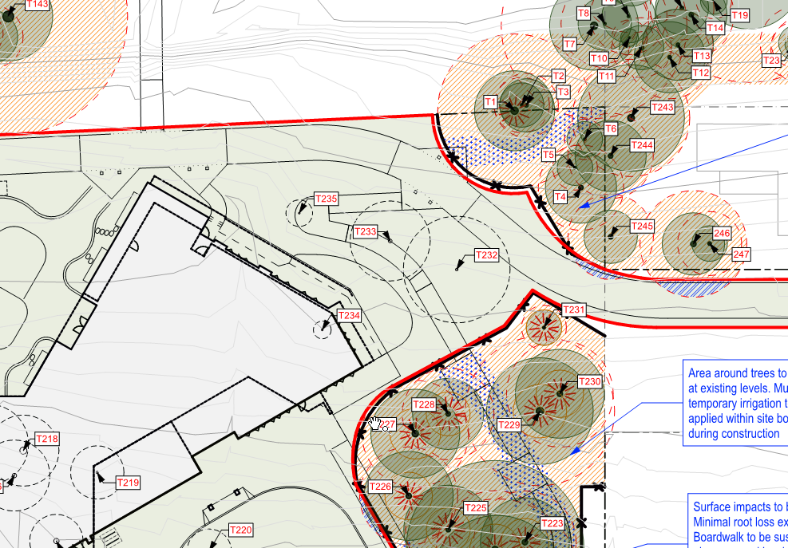

**Figure 1 – Extract from the Tree Protection & Removal Plan prepared by Arterra Consulting Arboriculture.**

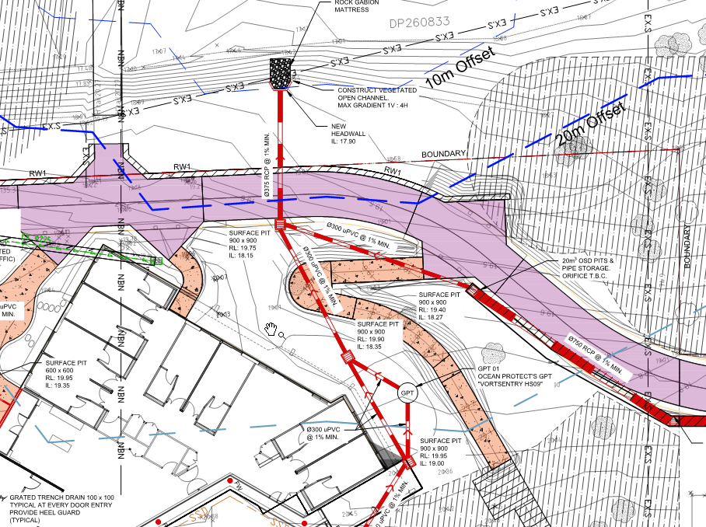

**Figure 2 – Extract from the Stormwater Drainage Part Plan prepared by Birzulis Associates**

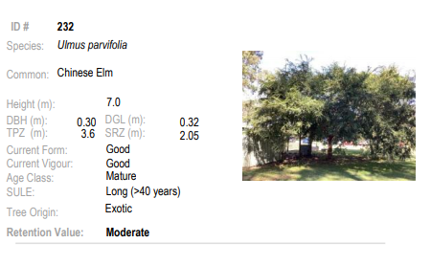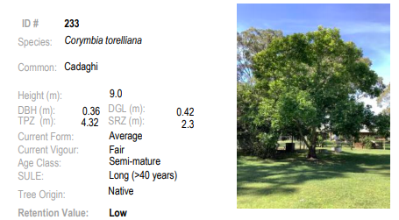

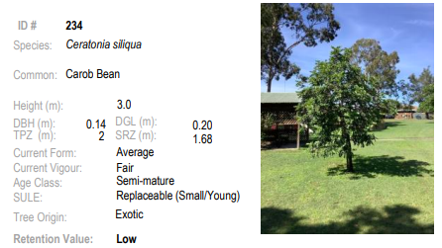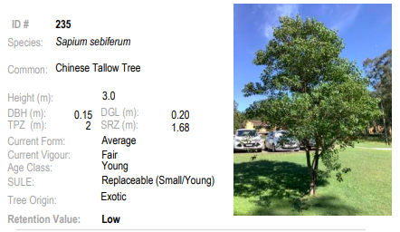

**Figure 3 – Extract from the Arboricultural Impact Assessment Report prepared by Arterra Consulting Arboriculture showing the subject trees.**

1. *Deletion of the pathway between RL 20.9 and emergency access point on the northern side of building and replacement with landscape and an amended landscape plan;*

The site plan, ground floor plan and landscape plan has been amended in red hatch to identify that this portion of the raised pathway is not approved. An additional condition of consent No 2 is recommended identifying this amendment. Condition 16 is recommended and requires a revised landscape plan to include additional landscaping in this location.

1. *Restriction on use of the emergency access point and deletion of concrete finish within the property boundary;*

Condition 24 has been amended to identify the full length to the road reserve is to be compacted gravel. Only the driveway crossing within the public footway is to be concrete construction. Recommend the insertion of Condition 25 to limit the use of the emergency access track.

1. *Management of APZ and obligations on applicant arising from legal advice;*

Conditions 6 to 10 are recommended to reflect this matter, as discussed above.

1. *Reference to amended plans regarding privacy lourve treatment;*

Condition 1 has been amended to identify the Privacy Analysis Plans submitted by the applicant that details the privacy lourve treatment. A copy of these plans are provided in Attachment 2.

1. *Reference to landscape detail along Erin Close boundary; and*

Condition 16 is recommended requiring a revised landscape plan to include amended landscape detail along the Erin Close boundary to ensure it is consistent with the stormwater drainage plan.

1. *No construction access over 42 Stronach Avenue and a requirement for a Construction Management Plan.*

Condition 25 includes a restriction of construction traffic over the proposed emergency access track within 42 Stronach Avenue. Condition 27e) required the preparation of a Construction Traffic Management Plan (CTMP) and has been amended to include reference to prohibiting any construction access over 42 Stronach Avenue.

**CONCLUSION**

The supplementary report is provided to address the reason for deferral within the record of deferral 8 December 2020. The proposed development is considered acceptable in terms of the relevant matters for consideration under the Act and the development application is recommended for approval subject to the imposition of consent conditions included as Attachment 1 to this report.